Research and Design of Unicycle Robot Based on Cascade PID Control

Jiacheng Huang

Maynooth International Engineering College, Fuzhou University, Fuzhou, China, 350100

Corresponding author: jiacheng.huang@ieee.org

Abstract

In robotics, achieving stable control of unicycles presents a significant challenge. However, standard balance control methods concentrate on regulating the position and static balance of the robot. Such techniques exhibit diminished performance in the presence of external disruptions or uncertain terrain. To enhance the stability and resilience of unicycles in dynamic settings, this research presents a double-flywheel unicycle robot that utilizes the conservation of angular momentum in a dual-gyroscope system to maintain its balance. Through the integration of mechanical design, electronic design, and controller design, a prototype of the unicycle robot is fabricated. For adaptive balance control, a cascaded PID controller based on MATLAB dynamic simulation is developed. The cascaded PID controller comprises angle, velocity, and angular velocity loops, enabling non-linear and coupled balance control. Moreover, using MECHANICS EXPLORERS, the disturbance rejection capacity of the designed cascaded PID controller is confirmed through pulse interference simulation. This study uses exercises that traverse ramps and maneuver corners to demonstrate the unicycle robot's dynamic balance. This exemplified the resilience of the entire balance system, demonstrating its capacity to recuperate from disruptions and uphold stability. The unicycle robot, in conjunction with the cascaded PID controller, can enhance response speed and achieve high-precision balance control performance, enabling stable motion in complex environments. This study significantly guides the development of newfound intelligent, flexible, and adaptable unicycle robots, providing novel ideas and approaches for future robot design and control.

**Keywords:** Unicycle robot, Dual-gyroscope system, Cascaded PID, Dynamic simulation

# INTRODUCTION

Currently, the normal operation of large equipment facilities such as factories and power plants is indispensable to production and life. Sending robots for inspection in hazardous or hard-to-reach places is a good choice. However, traditional four-wheeled robots are unable to reach designated target positions and have significantly reduced task completion rates in narrow entrances or confined spaces due to their large size and difficulties in steering. On the other hand, unicycle robots have been widely used due to their flexibility. [1] The unicycle robot has a simple structure, flexible movement, and the ability to cleverly avoid obstacles. It can easily adapt to complex terrains and achieve 360-degree free steering and movement in narrow spaces, which makes it better suited for various tasks in unique environments. However, the dynamics of a unicycle robot are complex, belonging to a typical nonlinear, strongly coupled, underactuated, and time-varying system. [2] The roll and pitch degrees of freedom of the unicycle robot are both nonlinear and statically unbalanced, with a significant coupling between them. These characteristics pose great challenges to the attitude control of unicycle robots. The unique features and the resulting control challenges make the research on unicycle robots of great theoretical significance and practical value. [3]

The development of the self-balancing unicycle can be traced back to 1987 when Schoonwinkel developed the first self-balancing unicycle. [4] Building on Schoonwinkel's design, Vos designed a linear quadratic regulator. [5] An LQR (Linear Quadratic Regulator) controller was used to accomplish balance control and position control on the unicycle robot created by the Asian Institute of Technology in Thailand. [6] In recent years, a structure combining an inertia wheel and a walking wheel has attracted the attention of scientists and engineers worldwide. This type of unicycle primarily draws inspiration from the principle of acrobats balancing on a tightrope by rotating a pole. It uses an inertia wheel to represent the balancing pole, which maintains lateral balance, and a walking wheel to represent the acrobat's motion, which maintains longitudinal balance [7]. However, the aforementioned design of the unicycle robot exhibits coupling between the pitch plane and the roll plane during dynamic analysis. This coupling becomes particularly prominent when it comes to disturbance rejection in maintaining balance. Experimental results demonstrate that significant coupling angle variations can introduce coupling disturbances.[8]

The previous studies demonstrate advancements in balancing unicycle robots. Nonetheless, when confronted with complex terrains, such as curves and slopes, a correlation between the balance angle and yaw angle occurs. This leads to intricate control, severe self-oscillation, and significant interference.[9] To tackle this problem, this paper aims to develop a controller for a double-flywheel unicycle robot that utilizes the conservation of angular momentum principle in the dual-gyro system to achieve balance, which controller enables steering control by decoupling the double flywheel groups.[10] This paper focuses on the hardware designs, algorithm development, controller simulation, and experimental design of the unicycle robot. In this research, the authors design a cascade PID controller, which combines the angle loop, velocity loop, and angular velocity loop to form the vertical loop and steering loop. This configuration allows for pitch balance, roll balance, and yaw balance. The cascade PID controller is dynamically simulated using the MECHANICS EXPLORERS tool, and pulse disturbance tests are carried out to confirm the precision and viability of the controller. The created balance controller is then used to create a prototype unicycle robot. Experimental designs are conducted on slopes and curves to validate the stability and robustness of the balance system through analysis of experimental data and images.

# Unicycle robot implementation

## Mechanical Designs

Unicycle robot model selected Beijing Keyu Tongbo unicycle robot model. As shown in Fig. 1, the unicycle robot utilizes two flywheels and a treaded wheel as its self-balancing architecture. The flywheels are symmetrically distributed in the front and back, tilted at a 45° angle with respect to the ground. The treaded wheel is located underneath the robot. Two brushless motors with a maximum speed of 6000 RPM control the flywheels to maintain roll balance and yaw balance. The DC geared motor with a maximum speed of 800 RPM controls the treaded wheel to maintain pitch balance. The brushless motors have built-in encoders that provide real-time speed readings through the main control board. The DC geared motor is equipped with a corresponding belt drive system, and the actual speed is detected by an encoder through gears.

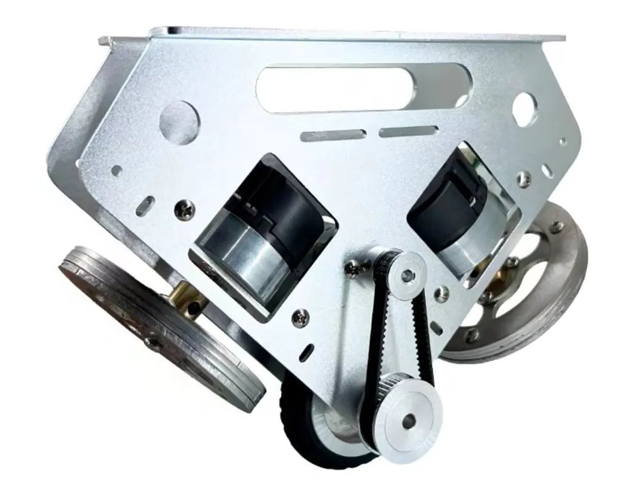 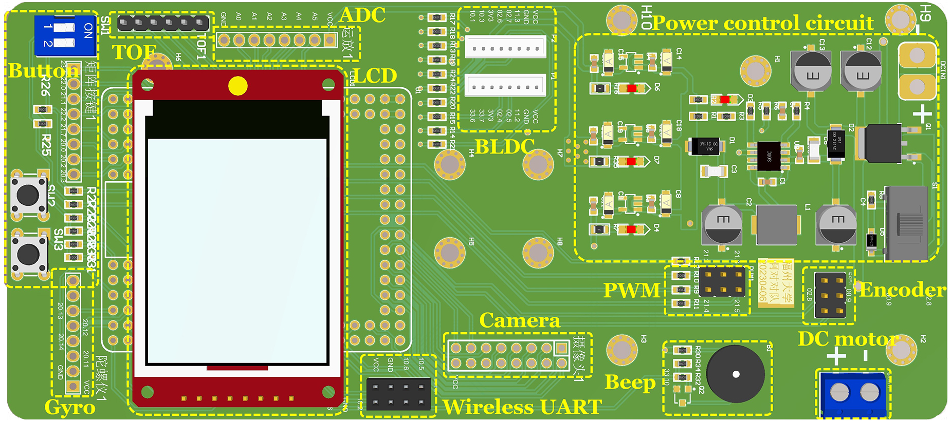

Figure 1. The body model of the unicycle robot. Figure 2. The main control circuit board of the unicycle robot.

## Electrical designs

In the main control circuit board (shown in Fig. 2), the main control chip uses the TC264DA developed by Infineon Technologies, a 32-bit TriCoreTM architecture with a main frequency of 200MHz. It has the characteristics of multi-core and high frequency, which enables it to handle complex control algorithms and meet the real-time and performance requirements of the unicycle robot balancing system. The main control circuit board integrates the main control chip, power management circuit, LCD, camera, gyroscope, buzzer, wireless serial port, and other peripherals, responsible for controlling the various modules of the unicycle robot.

The DRV8701 is used as the driver chip on the drive circuit board, which receives PWM signals from the main control chip to control the movement motor. The gyroscope uses MPU6050, which transmits the collected attitude information of the unicycle robot to the main control board through Kalman filtering. The unicycle robot is powered by a 24V(6S) lithium battery, and the SP1N28STER and RT9013 voltage regulator chips are used to build the DC-DC circuit and LDO circuit to provide 24V, 5V, and 3.3V voltages to each module. The overall hardware framework is shown in Fig. 3.

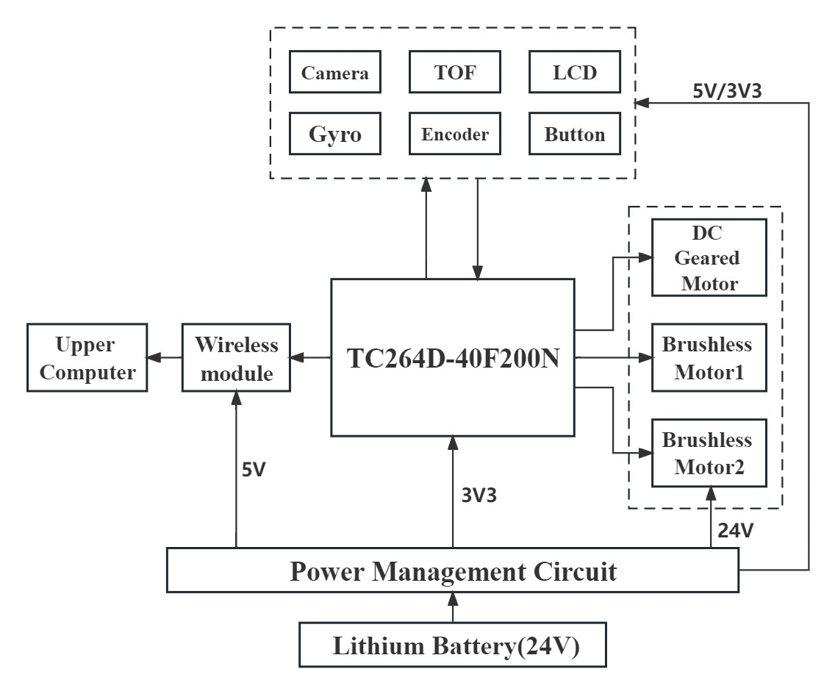

Figure 3. Hardware structure diagram

## Cascade PID architecture

Cascade PID is a commonly used control strategy to improve the control performance of a system. It consists of two or more PID controllers connected in a specific order. The structure of the cascade PID includes two levels: the outer loop and the inner loop. The main output variable of the outer loop control system is the input variable of the inner loop control system. This approach combines balance control and path detection control, effectively avoiding conflicts between balancing and steering, thereby enhancing system response speed and control accuracy. [11]

The inner ring controller's set point is determined by the output of the outer ring controller. [12] The inner loop controller's setpoint is derived from the output of the outer loop controller. To achieve more accurate control, the outer loop controller modifies the inner loop controller's setpoint based on the system's overall performance needs. The advantage of cascade PID is that it can provide better steady-state and dynamic responses. The outer loop controller can handle large variations in the unicycle balancing system, while the inner loop controller can more accurately adjust the system's subtle changes. The unicycle balancing state may be made more stable and resilient by using this hierarchical structure. The overall balancing design framework is shown in Fig. 4.

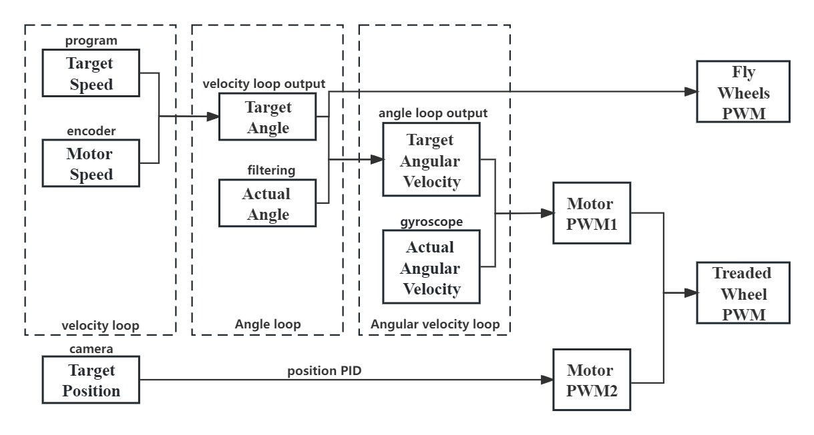

Figure 4. The control block diagram of the cascade PID system.

Software is written in C language, using the AURIX-Studio embedded development software and implementing the control software for the unicycle robot. The overall balancing framework adopts two sets of cascade PID structures, for the control of the traded wheel, a structure with two independent PIDs, the velocity loop, and the angle loop, is used in a cascade connection to control the pitch angle direction balance of the robot. For the control of the Flywheels, a structure with three independent PIDs, the angle, the velocity loop, and the angular velocity loop.

# Simulation

## Matlab simulation

Based on the cascaded PID principle mentioned above, this study conducted dynamic analysis and established the kinematic simulation of a self-balancing unicycle robot using MATLAB (Fig. 5).

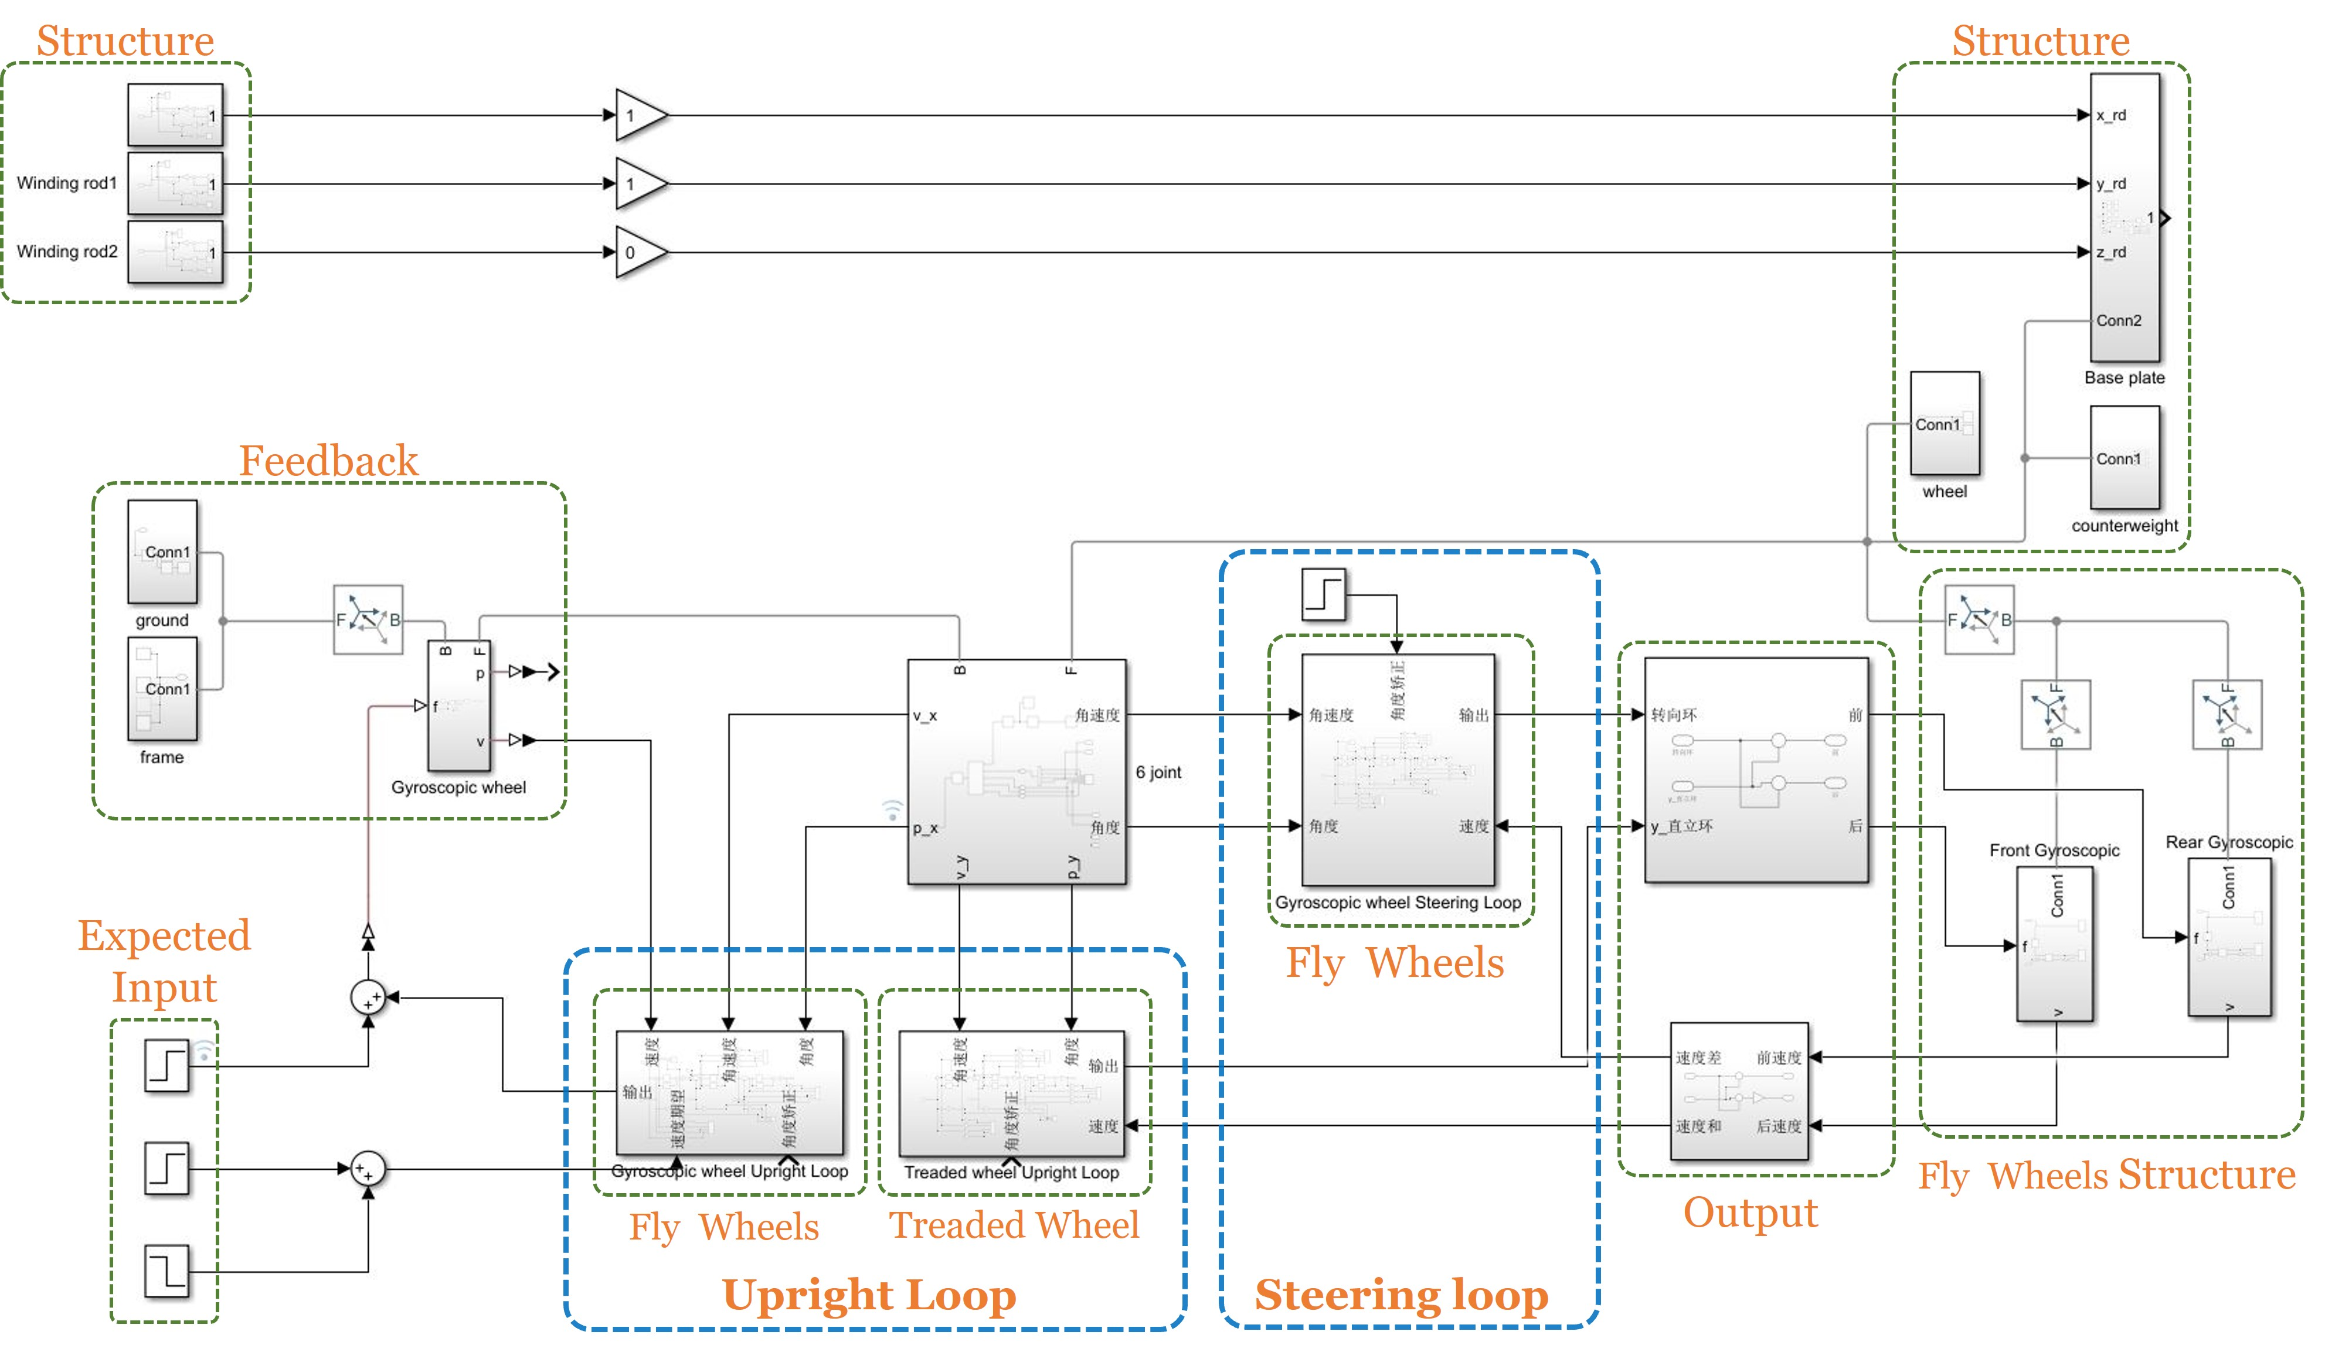

Figure 5. The simulation model block diagram of the unicycle robot.

In this cascaded PID controller, the velocity loop and angle loop are considered as the upright loop, while the velocity loop, angle loop, and angular velocity loop serve as the steering loop. The roll angle, pitch angle, and yaw angle, along with their respective angular velocities, are taken as the system parameter inputs. By comparing the roll angle and the desired roll angle, the rotation of the double flywheels at the front and rear of the unicycle robot, as well as the treaded wheel underneath, is controlled through the coordination of the upright and steering loops.

To investigate the static robustness and control effectiveness of the simulation system, the following experiment was designed. The target angular velocity and velocity of the unicycle robot were set to zero in the simulation system, and a pulse disturbance was applied to the pitch plane. A simulated external pulse disturbance experiment was performed, subjecting the pitch plane of the unicycle robot to a 3N for 25 seconds. The simulation captured the roll angle, pitch angle, yaw angle, and their respective angular velocities of the unicycle robot. The robustness and adaptability of the designed balancing system were evaluated through steady-state response curves and the dynamic model in MECHANICSE E XPLORERS. The continuous snapshots of the three-dimensional model of the unicycle robot in the simulation environment are shown in Fig. 6.

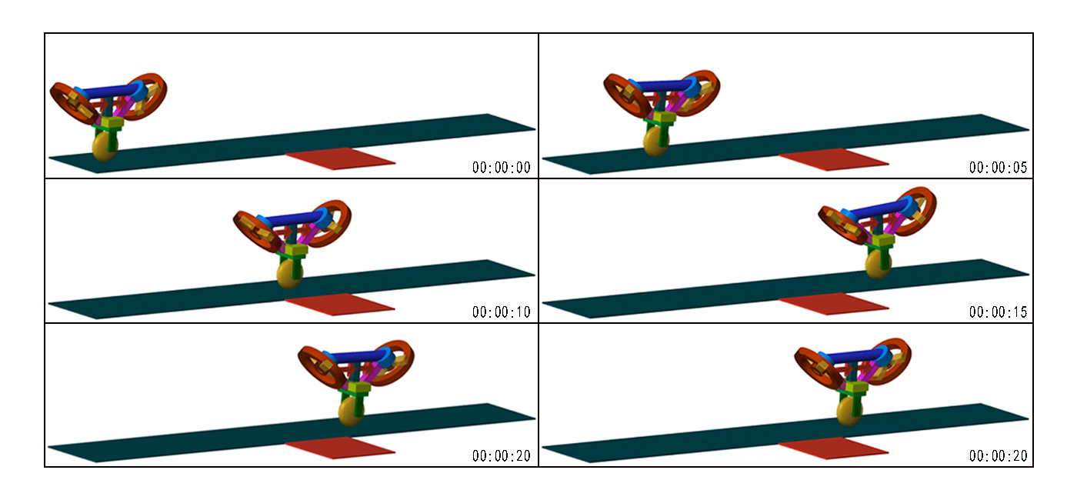

Figure 6. Photos from the simulation experiment.

## Results analysis

The curves graph in Fig. 7 illustrates the variation of angles and angular velocities over time in the pitch, roll, and yaw planes of the unicycle robot during the disturbance simulation experiment.

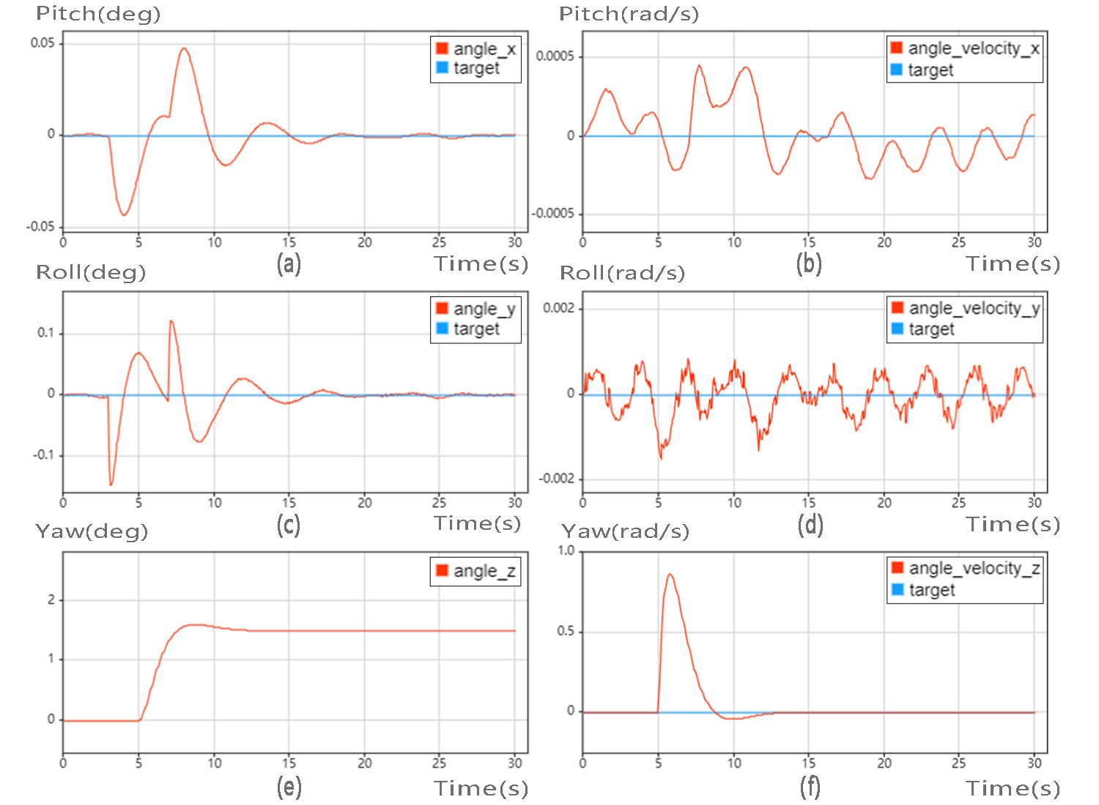

Figure 7. The impact curves of the unicycle robot in simulation. (a) Pitch angle; (b) Pitch velocity velocity;

(c) Roll angle; (d) Roll velocity velocity; (e) Yaw angle; (f) Yaw velocity velocity.

In Fig. 7(a), Fig. 7(c), and Fig. 7(e), the actual angles in the pitch roll and yaw angle are compared with the target angles in the simulation system. Initially, the pitch angle and roll angle hover around 0°. After approximately 3 seconds, a disturbance is applied to the controller through a step signal, resulting in an impact on the unicycle robot exceeding 2.5N, affecting its balance state.

In Fig. 7(a) and Fig. 7(c), the designed controller exhibits significant angle changes after the impact, but it manages to return to a balanced state within 5 seconds of the disturbance and reaches a steady state within 10 seconds, maintaining balance and returning to the initial static condition. The fluctuation effects on the yaw angle and forward angle are relatively small. The corresponding unicycle robot demonstrates strong balance adaptability in the pitch plane and roll plane.

In Fig. 7(e), the yaw angle is compared with the target angle in the simulation system. Initially, due to the significant variations in pitch and roll angles caused by external forces, the yaw angle undergoes certain directional changes. However, since no target planning is applied to the yaw angle in the system, it stabilizes without returning to the initial angle after the pitch and roll angles stabilize. This aligns with the expected behavior of the system.

Figures Fig. 7(b), Fig. 7(d), and Fig. 7(f) depict the angular velocities of the pitch, roll, and yaw angles under disturbances. The ideal angular speed should be maintained within a range close to 0 rad/s. However, due to the influence of pulse interference, the angular speed will rapidly change to correct the balance posture of the unicycle robot body.

In Fig. 7(b) and Fig. 7(d), it can be seen that throughout the experiment, the simulated system's roll angular velocity and pitch angular velocity remain stable within the range of ±0.002 rad/s, with smooth fluctuations, proving that the physical prototype is in a state of dynamic lateral balance.

In Fig. 7(f), it can be observed that after disturbances, the acceleration in the Z-axis quickly returns to the normal range and stabilizes, with smooth fluctuations, indicating that the simulated model is in a state of dynamic lateral balance. Thus, the self-balancing controller designed under disturbances exhibits strong resistance to interference and can reduce coupled disturbances.

# experiments

The cascaded PID controller designed earlier was transplanted onto the MCU of the physical unicycle robot. With parameter adjustments of the cascaded PID controller, the unicycle robot achieved basic upright stance and locomotion capabilities. The controller parameters are presented in Table 1.

Table 1. The parameter for the cascaded PID controller

|  |  |  |  |  |
| --- | --- | --- | --- | --- |
| **Wheel Type** | **Loop Type** | **KP** | **KI** | **KD** |
| Treaded wheel | Angle Loop | 0.04 | 0.4 | 0.1 |
| Velocity Loop | 0.03 | 0 | 0 |
| AngleVelocity Loop | 80 | 0.1 | 3 |
| Flywheel | Angle Loop | 0.15 | 0 | 0.25 |
| Velocity Loop | 0.16 | 0.002 | 0 |
| AngleVelocity Loop | 80 | 0 | 30 |

(a) (b)

Figure 8. The curves of the unicycle robot in the upright experiment. (a) Temporal evolution of angle;

(b) Temporal evolution of angular velocity.

After adjusting the PID parameters, the initial pitch angle of the unicycle robot is less than 20°. Upon activation, the unicycle robot quickly starts to swing. The variation curves of the angle and angular velocity during the swing experiment of the unicycle robot are shown in Fig. 8. The unicycle robot maintains balance after 3 seconds and reaches a steady state after 4.5 seconds. Therefore, it can be concluded that the controller has achieved static balance for the unicycle robot.

To evaluate the robustness of the unicycle robot system controller under dynamic conditions, this study conducted two experiments that affect self-balancing: the ramp traversal experiment and the corner maneuver experiment.

## Ramp traversal experiment

To validate the performance of the controller in the pitch plane under dynamic conditions, this study designed a ramp with an inclination angle of 20°. As the unicycle robot moves on the ramp, the pitch plane undergoes constant changes, requiring the unicycle robot to continuously adjust the rotation of the momentum wheel and the driving wheel to maintain overall balance. In this experiment, the target speed of the unicycle robot was set to an output PWM of 500. Fig. 10 shows the image capture of the unicycle robot traversing the ramp within 10 seconds.

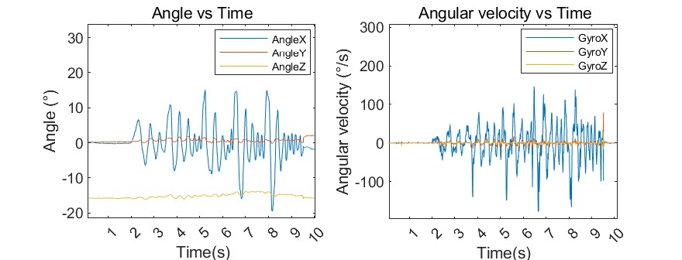

(a) (b)

Figure 9. The curves in the ramp traversal experiment. (a) Temporal evolution of angle; (b) Temporal evolution of angular velocity.

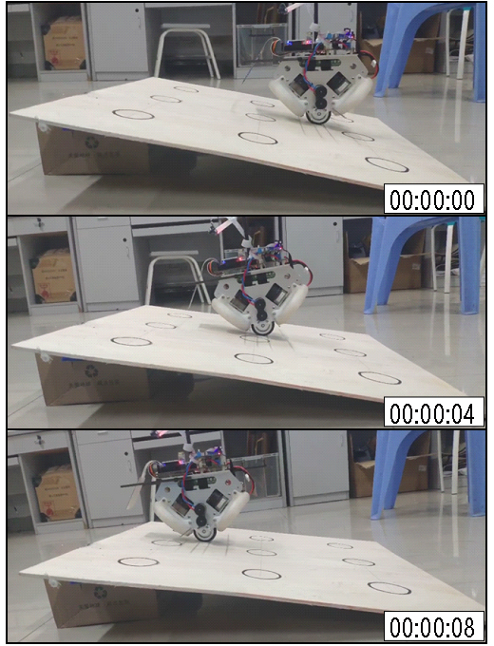

Figure 10. The photos in the ramp traversal experiment.

In Fig. 9(a), it can be observed that during the ascent along the ramp, the pitch angle of the frame experiences disturbances between 5° and 15° and quickly oscillates before damping, converging to the vicinity of the zero position after approximately 1 second. It is evident that with the adjustment of the cascaded PID controller, the unicycle robot's pitch plane can be rapidly regulated, causing the frame to swing back and forth, and then the body returns to the balanced position. The maximum variation in the roll plane and yaw plane angles is around 3°, remaining relatively stable.

In Fig. 9(b), it can be observed that during the ascent process, to ensure the rapid convergence of the pitch plane, the angular velocity of the pitch angle is proportional to the distance from the balanced position. In the presence of disturbances, it also converges to approximately 50°/s within 1 second. When the pitch plane is kept balanced, the angular velocities in the roll plane and yaw plane remain relatively unchanged, indicating a gradual return to normal speed for the momentum wheel. Therefore, it can be concluded that the control scheme achieves dynamic balance in the pitch plane.

## Corner maneuver experiment

To validate the performance of the controller in the roll plane and yaw plane under dynamic conditions, this study designed a curved track with an angle of 180°. The position information was obtained through a camera, and the route was planned accordingly. As the unicycle robot moves along the curved track, the roll plane and yaw plane constantly change, requiring the unicycle robot to continuously adjust the rotation of the momentum wheel and the driving wheel to maintain overall balance. In this experiment, the target speed of the unicycle robot was set to an output PWM of 300. Fig. 11 shows the continuous image capture of the unicycle robot traversing the curved track within 20 seconds.

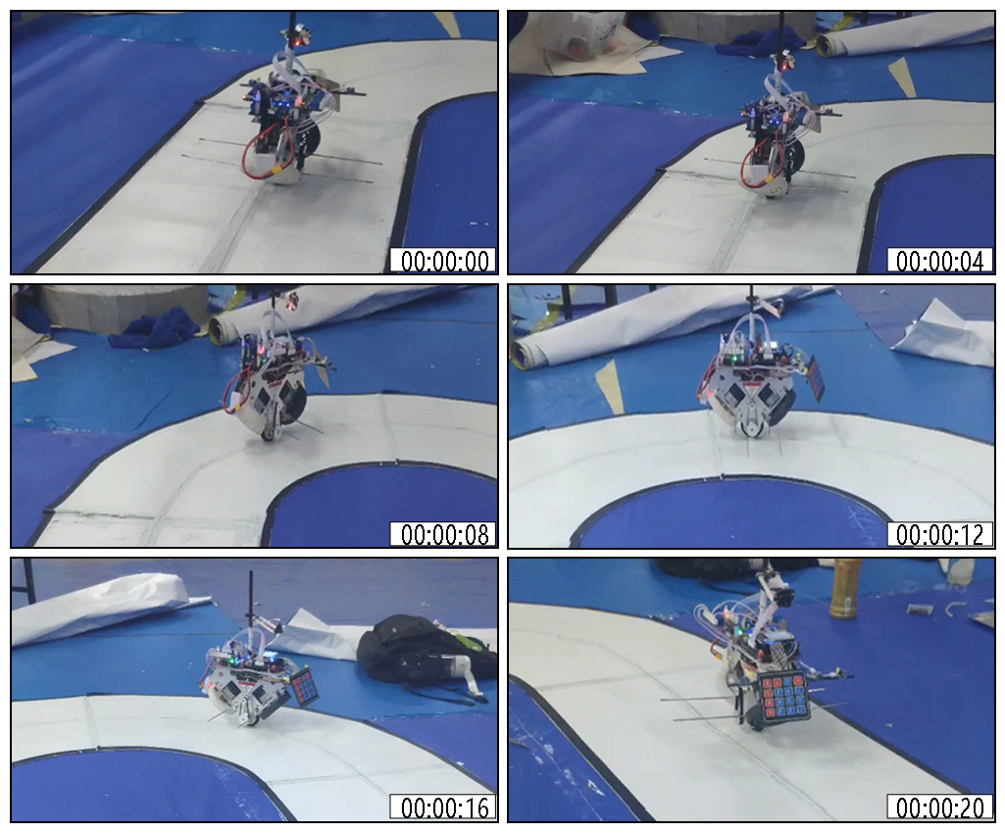

Figure 11. The photos in the corner maneuver experiment.

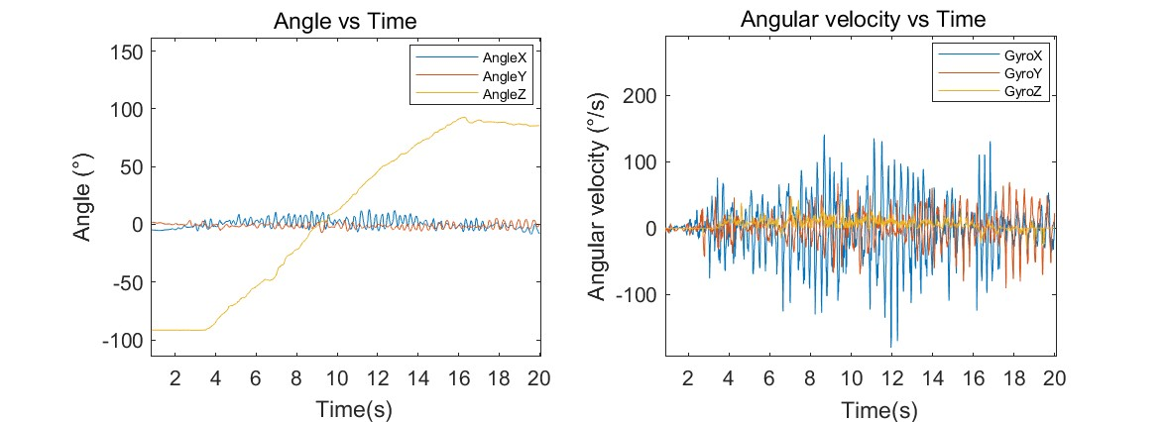

(a) (b)

Figure 12. The curves in the corner maneuver experiment. (a) Temporal evolution of angle;

(b) Temporal evolution of angular velocity.

In Fig. 12(a), the yaw angle changes by approximately 180° within 20 seconds, and the change occurs at a relatively uniform speed. This indicates that the controller exhibits excellent control performance for steering the unicycle robot. Additionally, the pitch plane and roll plane exhibit oscillations around the 0° position under the influence of the motor's control torque. This result suggests that the unicycle robot maintains good balance performance while traversing the curved track.

In Fig. 12(b), the angular velocity of the yaw angle changes relatively smoothly, remaining within approximately ±50°/s throughout the entire experiment. Although the overall variation in the pitch angle and roll angle is not significant, their angular velocities vary greatly, with some exceeding 100°/s. This is because changes in the yaw angle of the unicycle robot affect the pitch angle and roll angle. To maintain balance, the brushless motor needs to exert a significant torque to ensure the body returns to the upright position. Therefore, it can be concluded that the control scheme achieves dynamic balance in the roll plane and yaw plane.

Analyzing the experimental data presented above, it can be concluded that the control parameters obtained from the simulation have valuable practical implications for control parameter tuning and dynamic balance control. There is a commonality between dynamic simulations and real-world experiments in the field of robotics. Although the photographs demonstrate the phenomenon of retaining balance at non-zero angles, this behavior can be attributed to the mechanical structure's poor symmetry and the unicycle robot's gyroscope's improper vertical alignment in the lateral direction. The proposed cascaded PID controller design, which facilitates the unicycle robot system's gradual stability and allows balanced control in the pitch, roll, and yaw planes under both dynamic and static conditions, is proven effective by the consistency between simulation results and physical experiments.

# Conclusion

To address the poor control performance of traditional unicycle robots in dynamic systems and complex environments, this paper proposes a unicycle robot system based on a double-flywheel unicycle robot along with its controller. The controller is subjected to dynamic simulation and experiments in MATLAB to evaluate the robustness of the balancing system under disturbances. Subsequently, physical experiments are conducted on curved paths and slopes to effectively reveal the kinematic coupling between the motion control of the driving wheel and flywheels of the unicycle robot and the dynamic attitude angles of pitch, roll, and raw. The experimental results demonstrate that the self-balancing unicycle robot designed in this study exhibits good robustness in dynamic environments.

However, the effective achievement of dynamic balance through the proposed balancing controller, this study still has limitations. The conservation of angular momentum in the double-flywheel system serves as the foundation for the balancing control approach suggested in this work. In cases where there are significant changes in the yaw angle, the unicycle robot may experience "momentum wheel saturation." This phenomenon can affect the balance performance and maneuverability of the unicycle robot. In the future, this study will improve the structure of the unicycle robot, explore more suitable weight distribution for the robot, optimize the design of the flywheels, and refine the control strategy for the flywheels. This will enable the management of speed and torque distribution of the flywheels, thereby avoiding the occurrence of momentum wheel saturation. In general, this study proposes an advanced control system for a unicycle robot that demonstrates excellent control performance in complex environments and dynamic systems. This holds significant implications for enhancing the control capabilities of unicycle robots in complex environments, providing a valuable solution for practical applications in areas such as unicycle robot inspections and mobile robotics in real-world scenarios.

References

1. Ríos H., Mera M. and Polyakov A., "Perturbed Unicycle Mobile Robots: A Second–Order Sliding–Mode Trajectory Tracking Control,". IEEE T. Ind. Electron, 71(3), 2864-2872 (2023).
2. Neves G P. and Angélico B A., "A discrete LQR applied to a self-balancing reaction wheel unicycle: Modeling, construction and control," 2021 American Control Conference (ACC). IEEE, New Orleans, LA, USA, 777-782 (2021).
3. Shen J. and Hong D., "Omburo: A novel unicycle robot with active omnidirectional wheel," 2020 IEEE International Conference on Robotics and Automation (ICRA). IEEE, Paris, France, (2020)
4. Schoonwinkel, A., “Design and test of a computer-stabilized unicycle. Stanford University”, Ph.D. Thesis (1988).
5. Vos D W., "Nonlinear control of an autonomous unicycle robot: practical issues," Ph.D. Thesis, Massachusetts Institute of Technology (1992)
6. Chantarachit S. and Parnichkun M., "Development and control of a unicycle robot with double flywheels," Mechatronics, 40, 28-40 (2016).
7. Ge Y., Zhang A. C., Huo J. Z., Duan S. W., Lei W., Kang J. S., "Dynamic modeling and stability control of unicycle acrobatic robot," Automation application, 3, 101-103 (2017)
8. Zhang Y., Jin H., Wang B. and Zhao J., "Balancing control of a unicycle robot with double gyroscopes using adaptive fuzzy controller," Mechatronics, 88, 102908 (2022)
9. Zhang Y., Jin H. and Zhao J., "Dynamic Balance Control of Double Gyros Unicycle Robot Based on Sliding Mode Controller," Sensors, 23(3), 1064 (2023)
10. Chantarachit S., "Design and simulate of LQR-Fuzzy controller for unicycle robot with double flywheels," MATEC Web of Conferences. EDP Sciences, 192: 02001 (2018)
11. Li F., "Research on self-balancing unmanned bicycle based on cascade PID control," IEEE 2nd International Conference on Information Technology, Big Data and Artificial Intelligence (ICIBA). IEEE, Chongqing, China, 2, 442-446 (2021)
12. Huang Y., Chen H., Qin L., "Design of self-balancing vehicle based on cascade PID control system," 4th International Conference on Advances in Computer Technology, Information Science and Communications (CTISC). IEEE, Suzhou, China, 1-4 (2022)